**Airlines Management System**

1. **Login Screen** 
   1. Click on ‘New Customer-Click Here!’

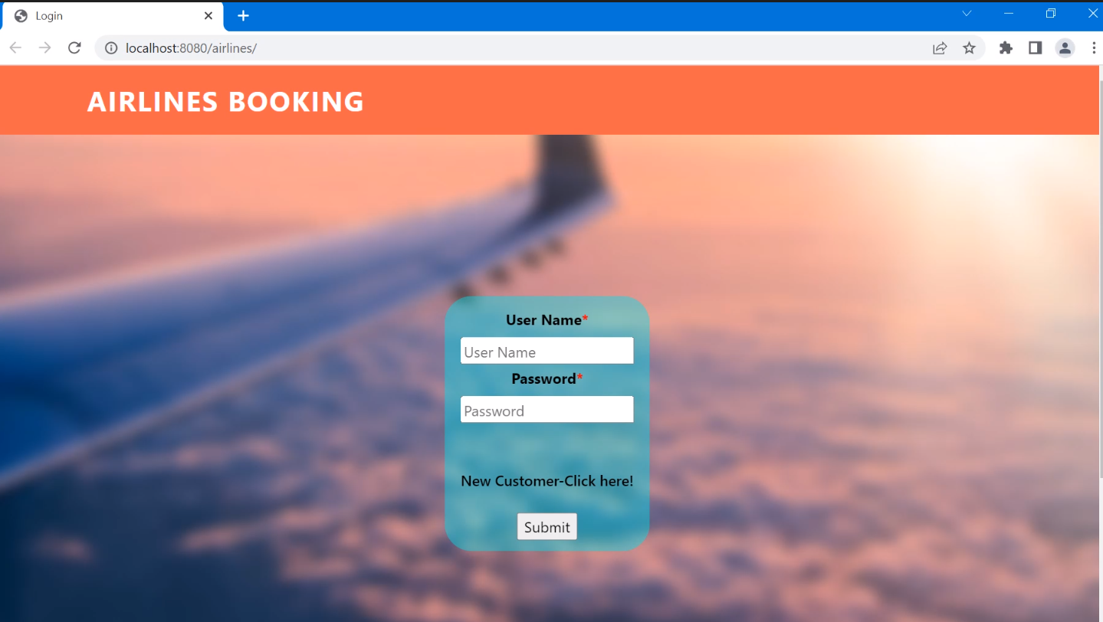

1. **Register New User**
   1. Enter ***invalid data*** for any field. Error message will be displayed with the specific detail.

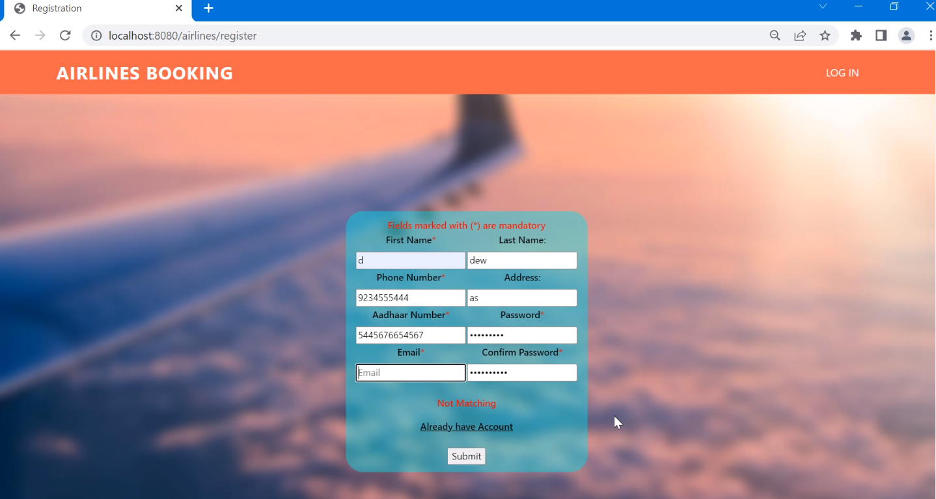

* 1. Enter all the mandatory fields with ***valid data*** and click on Submit

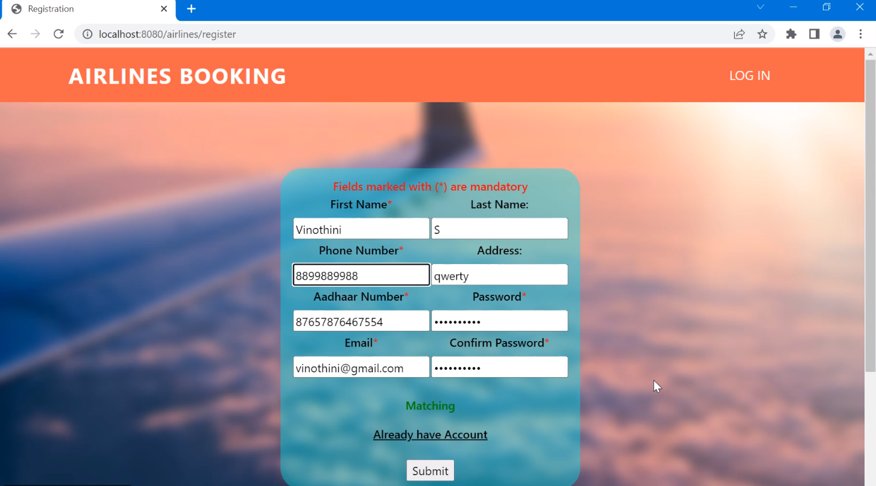

* 1. User will be redirected to **Login Screen**.
     1. Enter ***invalid credentials*** and click on submit. Error Message ‘Wrong Credentials’ will be displayed

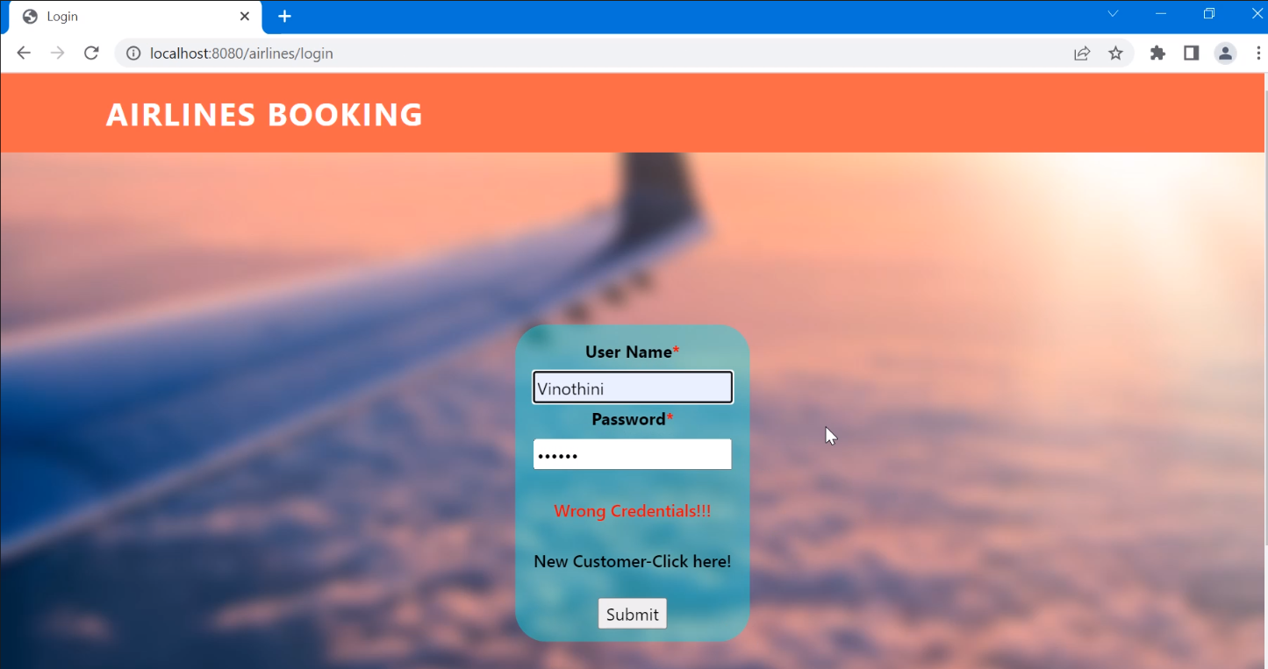

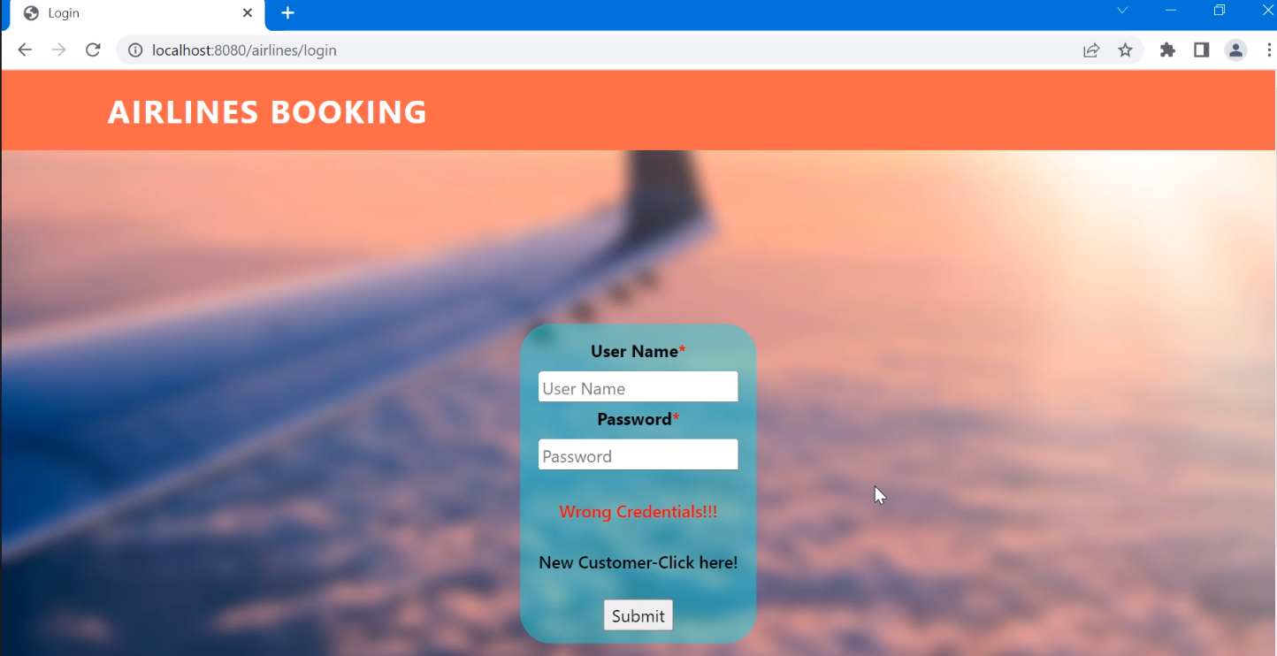

* + 1. Enter ***Valid credentials*** and Click on Submit

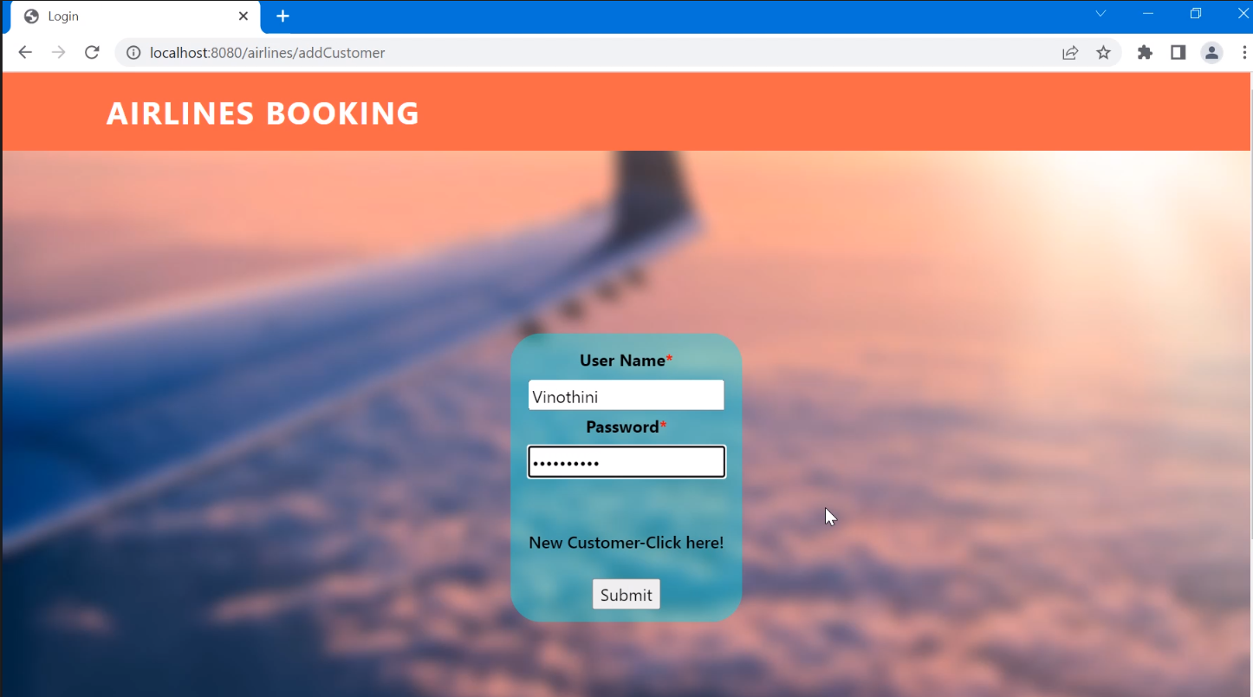

* + 1. User will be redirected to the home page
    2. Book Flight Ticket, Print Ticket, Print All Tickets

1. **‘Book Flight Ticket’ Page**

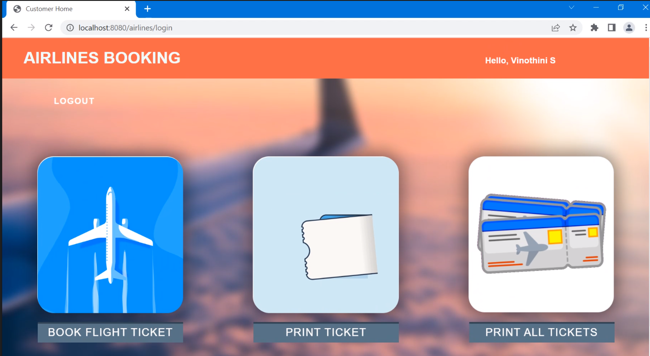

* 1. Blank Flight Ticket Booking Form with necessary fields will be displayed

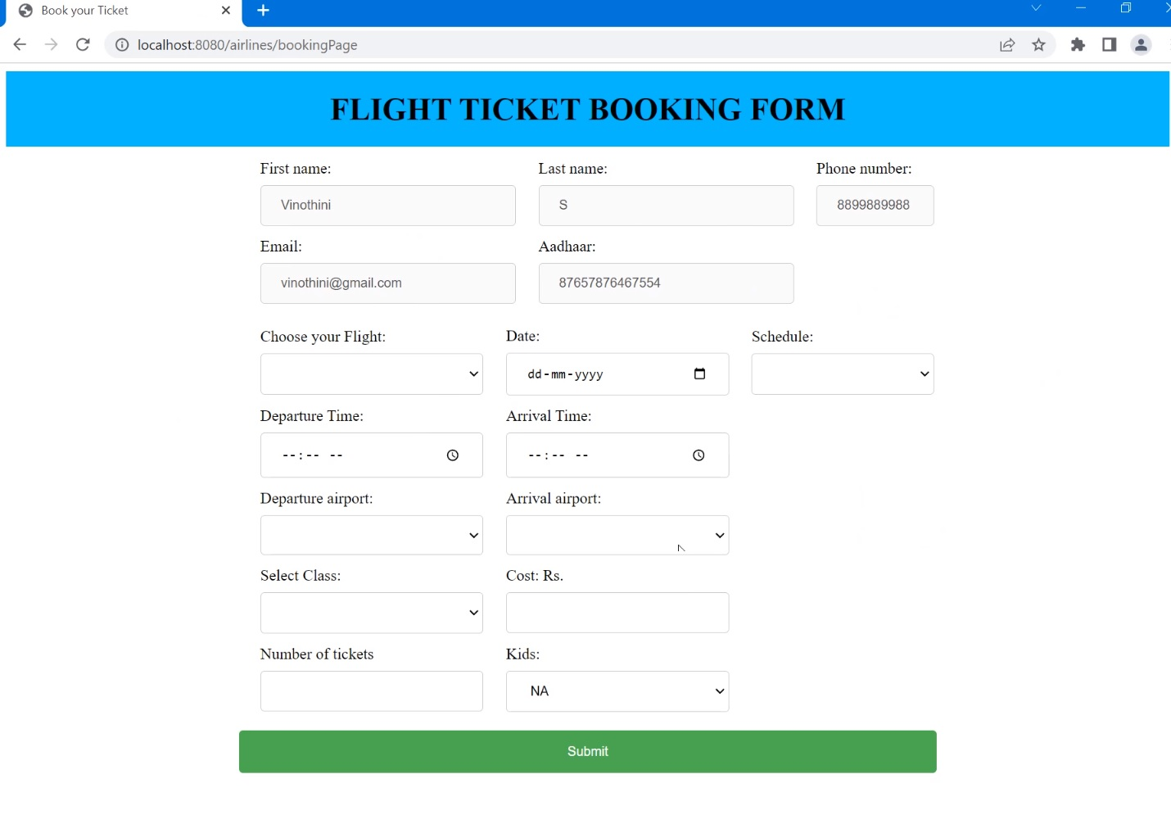

* 1. Enter valid details

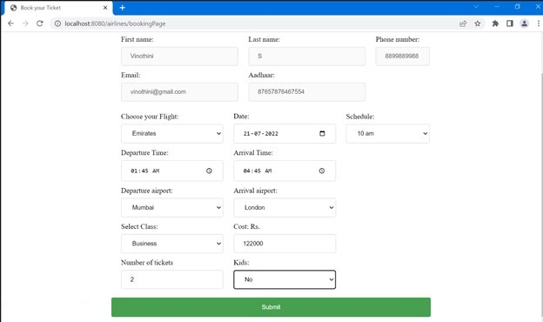

* 1. Past date cannot be selected

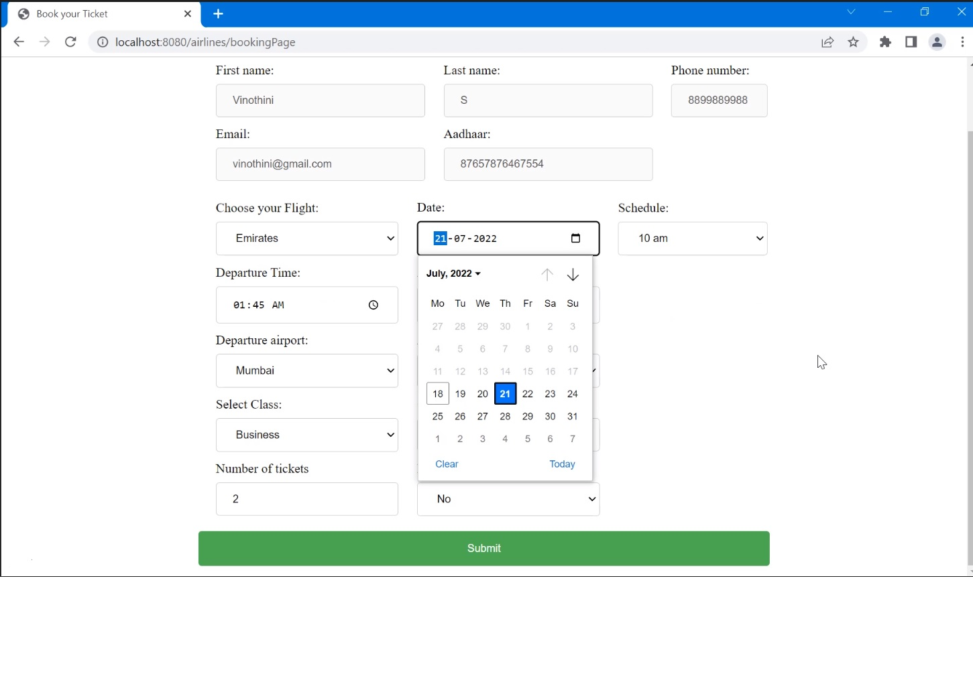

* 1. Departure and Arrival Airport should not be the same

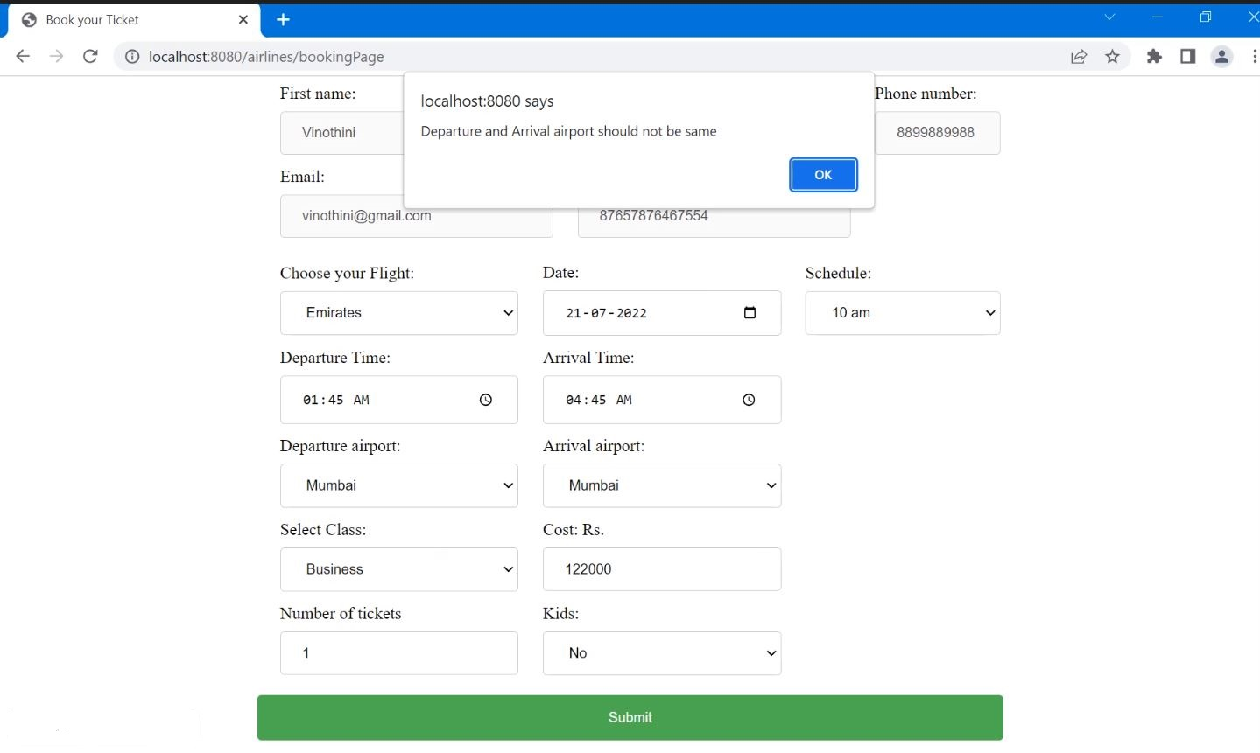

* 1. Enter all the valid details and click on Submit. Ticket will be booked and the details will be displayed in a separate page

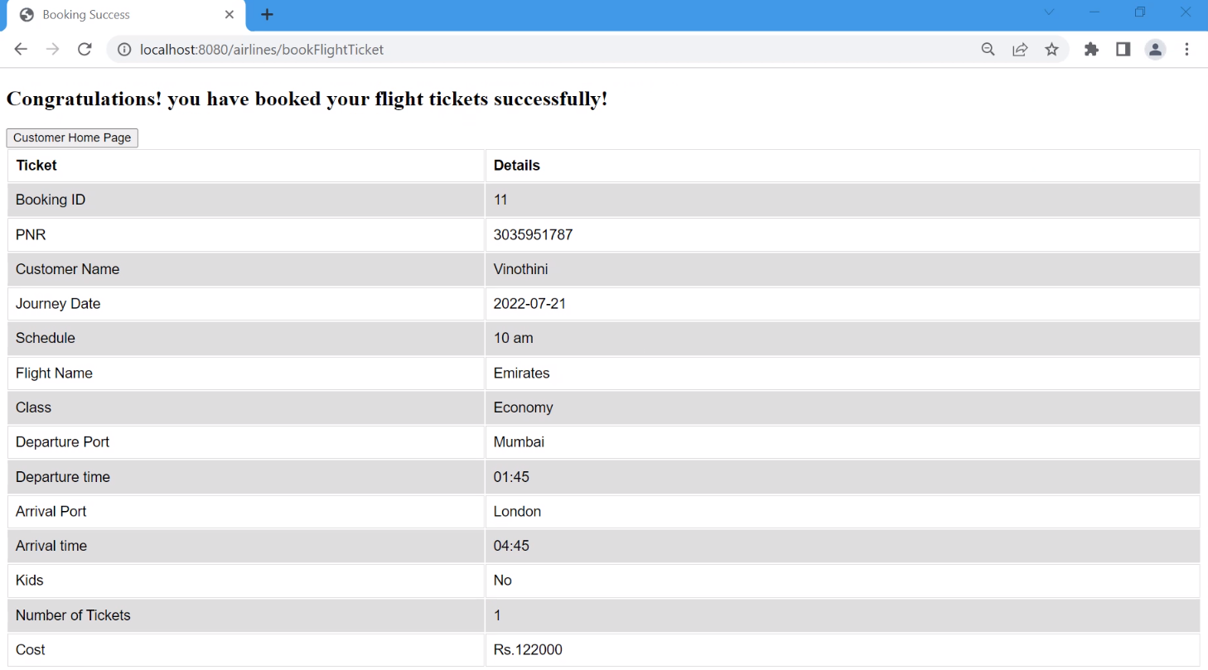

1. **Print Ticket Page**
   1. Enter the PNR number and click on Submit.

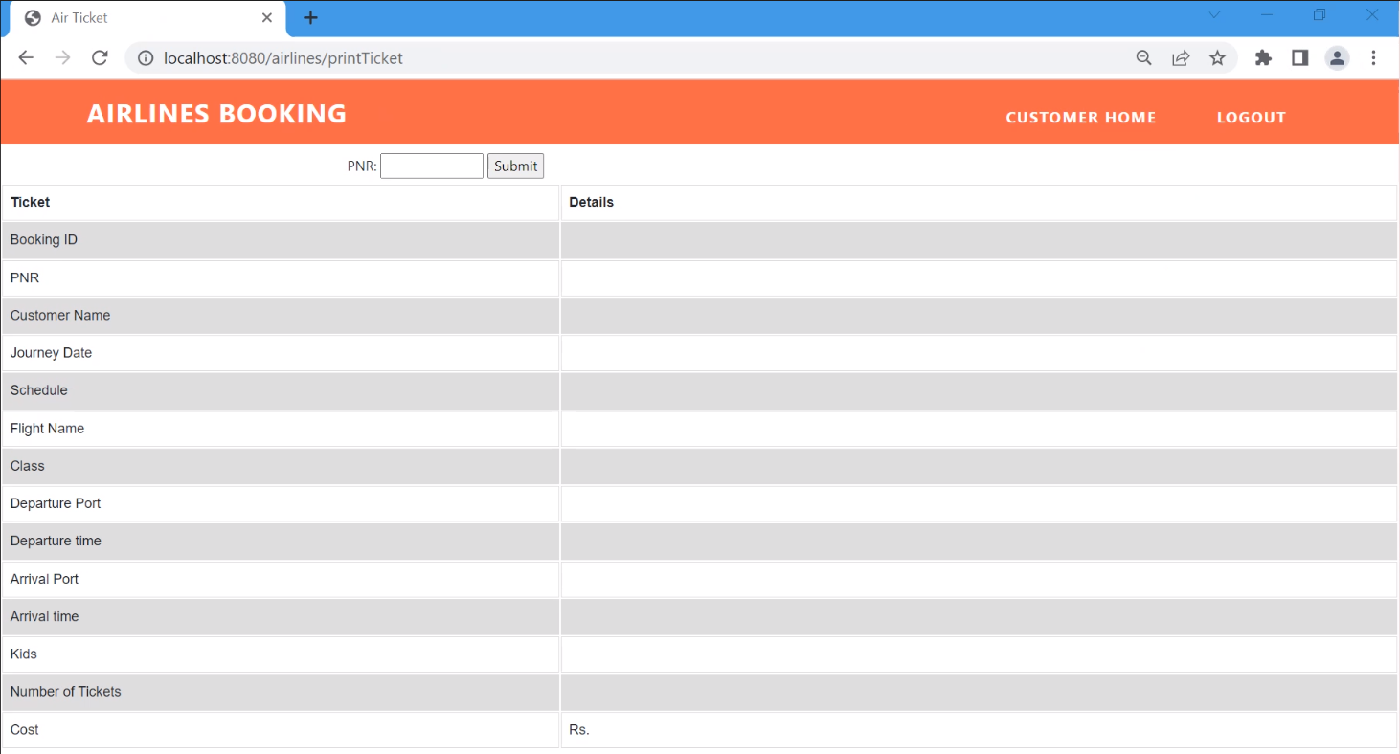

* 1. Flight booking details for the entered PNR will be displayed in the screen

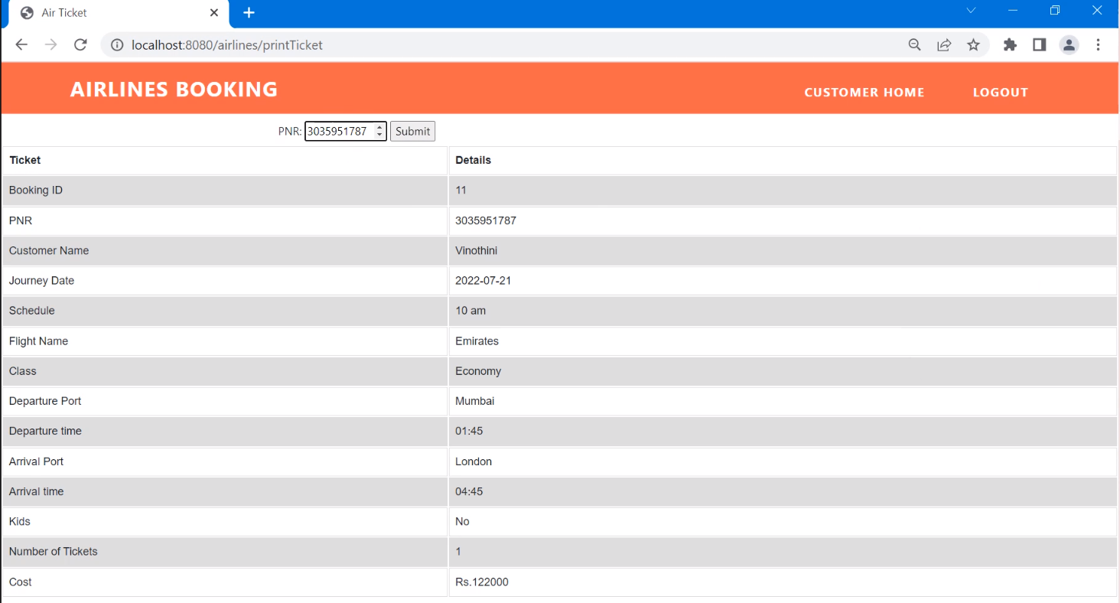

1. **Print All Tickets Page**
   1. Click on Print All Tickets



* 1. Flight Booking details for the logged in user will be displayed

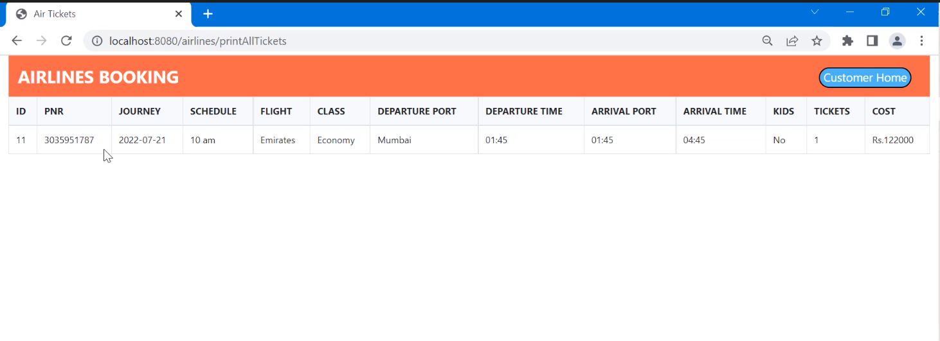

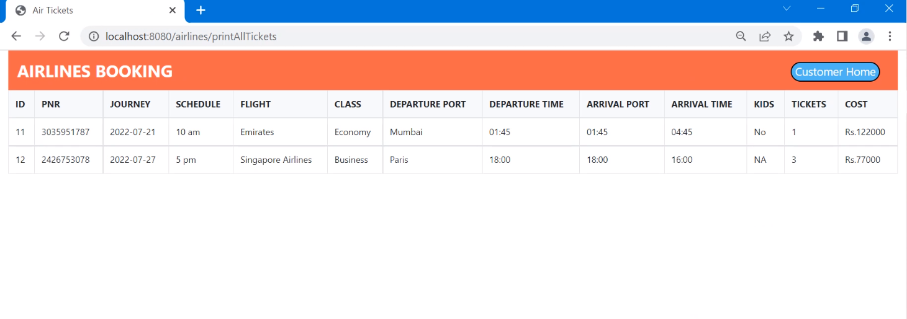

**Login as Admin**

1. Login with the Admin User ID details

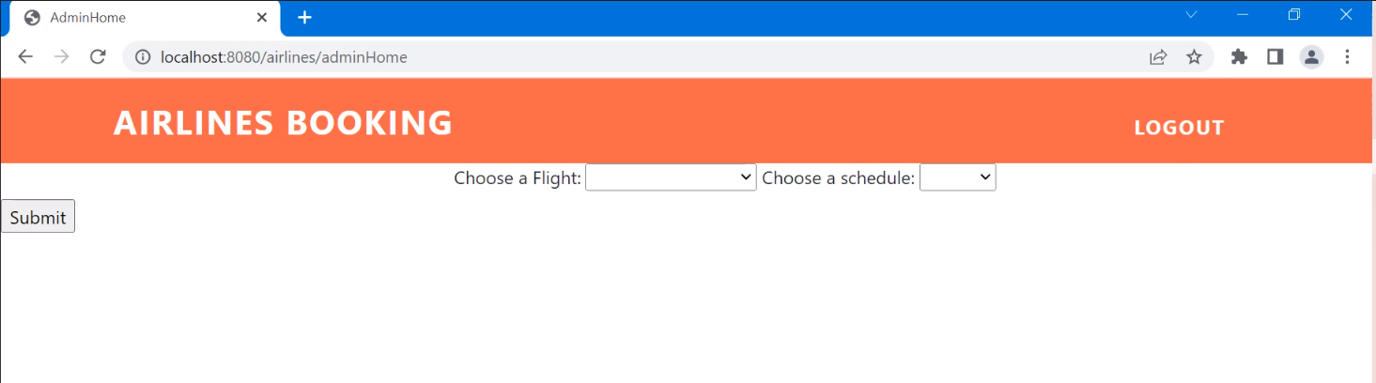

1. Choose the flight and schedule from the dropdown fields and click on Submit
2. All the user details for the selected Flight and schedule will be displayed

